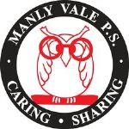
Manly Vale Public School
Our Vision
‘It takes a village to raise a child’
As leaders in public education, we are a community of learners who are committed to working together to provide high quality, innovative academic, wellbeing and sustainable educational programs.

At Manly Vale Public School, our school community works together to ensure every child has a positive, happy and rewarding school experience. Students, teachers, parents and carers are genuine partners in the learning process, ensuring students are encouraged to:
Our
Mission
      - strive and achieve their personal best
      - be considerate and empathic community members
      - become lifelong learners
Our Values
A collaborative learning community works together…
Excellence Equity Accountability Trust
Integrity Service

Our Strategic Directions
Strategic Direction 1: Engaged and challenged learners

Strategic Direction 2: Leaders in Learning

Strategic Direction 3: Connected Community

